**Ex: No: RECRUITMENT SYSTEM**

**Date:**

**AIM:**

To Design, Implement and Test the Recruitment Systemdescribed in the given problem statement .

**PROBLEM STATEMENT:**

The recruitment system allows the job seekers to view the job opportunity through Advertisement and helps to apply for the job. The Applicants apply for the job. Once the applicant enrolls he/she receives an ID which helps in further correspondence. The Registered applicants undergo through a process of Test and Interview. The HR Department can also get the list of available candidates and shortlist for their company requirement. The HR department selects the Applicant based on the performance in the Test and Interview. Finally the recruited applicants are informed. This system makes the task of the job seeker easier rather than waiting in queue for enrollment. This also reduces the time consumption for both for the job seeker and organization. It generates results for the test taken up by the candidates and the employers in the recruitment process in a periodical base. The Organization is given rights to add or delete Applicant profiles, provide information about company, publish results for test and job confirmation. HR Department is given rights to access the recruiting information and if needed, make changes to them.

**USECASE DIAGRAM:**

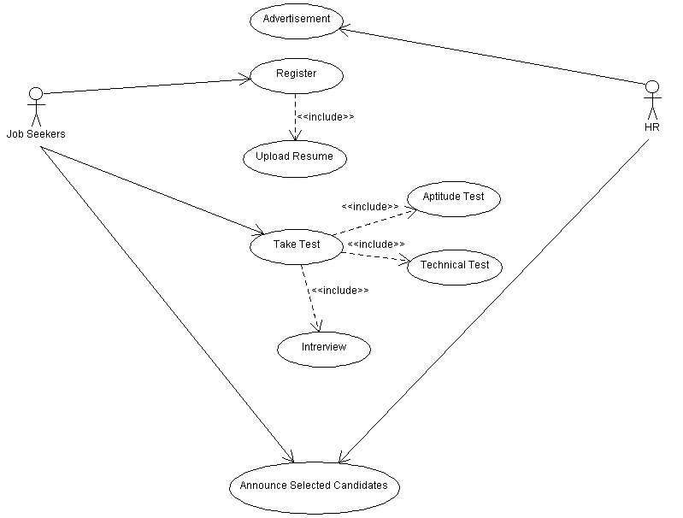

**CLASS DIAGRAM:**

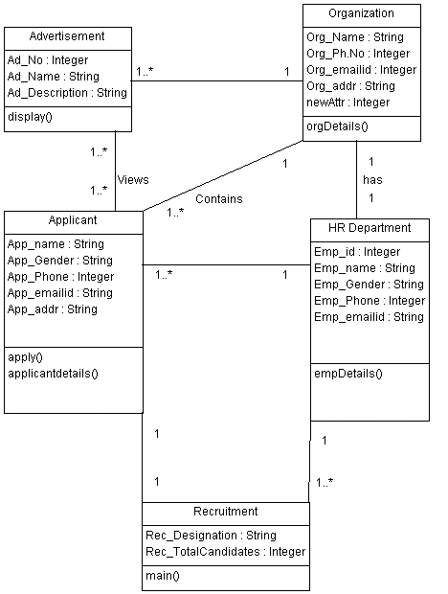

**SEQUENCE DIAGRAM:**



**COLLABORATION DIAGRAM:**

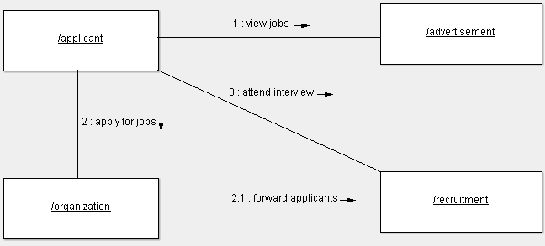

**ACTIVITY DIAGRAM:**

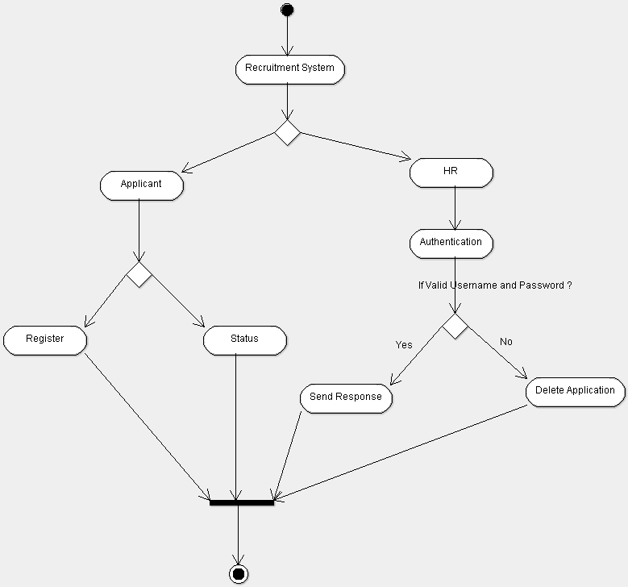

**STATE CHART DIAGRAM:**

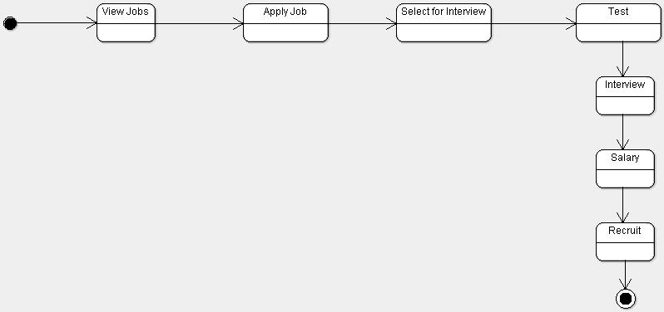

**COMPONENT DIAGRAM:**

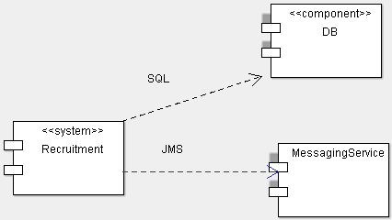

**DEPLOYMENT DIAGRAM:**

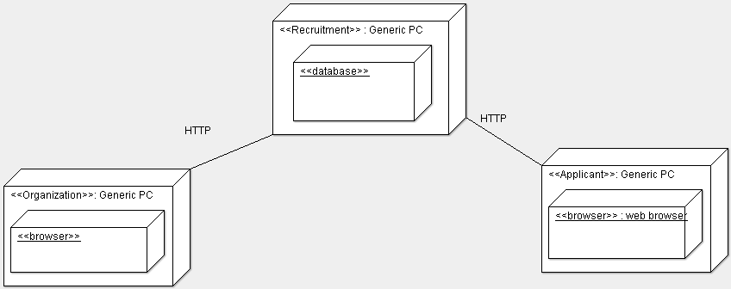

**IMPLEMENTATION & TESTING**

**Applicant.java**

package Recruitment;

import java.util.Scanner;

public class Applicant

{

int i;

String app_name[]= new String[10];

String app_gender[]= new String[10];

String app_phone[]=new String[10];

String app_mail[]=new String[10];

String app_addr[]=new String[10];

void apply()

{

for(i=0;i<5;i++)

{

Scanner sc=new Scanner(System.in);

System.out.println("Enter the Applicant "+(i+1)+" Name: ");

app_name[i]=sc.next();

System.out.println("Enter the Applicant "+(i+1)+" Gender: ");

app_gender[i]=sc.next();

System.out.println("Enter the Applicant "+(i+1)+" Mobile Number: ");

app_phone[i]=sc.next();

System.out.println("Enter the Applicant "+(i+1)+" Mail ID: ");

app_mail[i]=sc.next();

System.out.println("Enter the Applicant "+(i+1)+" Address: ");

app_addr[i]=sc.next();

}

}

void applicantdetails()

{

for(i=0;i<5;i++)

{

System.out.println("=========================================================");

System.out.println("Applicant ID: "+(i+1));

System.out.println("Applicant Name: "+app_name[i]);

System.out.println("Applicant Gender: "+app_gender[i]);

System.out.println("Applicant Mobile Number: "+app_phone[i]);

System.out.println("Applicant Mail ID: "+app_mail[i]);

System.out.println("Applicant Address: "+app_addr[i]);

System.out.println("=========================================================");

System.out.println("");

}

}

}

**Organiztion.java**

public class Organization

{

String Name="NewTechPvt.Ltd.";

String Mail="admin@NewTech.com";

String Mobile="7010747741";

String Address="No.2,Rajaji Street,Guindy,Chennai-28";

void orgDetails()

{

System.out.println("__________________________________________________________________");

System.out.println("Organization Name: "+Name);

System.out.println("Organization Mail ID: "+Mail);

System.out.println("Organization Mobile Number: "+Mobile);

System.out.println("Organization Address: "+Address);

System.out.println("__________________________________________________________________");

System.out.println("");

}

}

**HRDepartment.java**

public class HRDepartment

{

String[] Emp_name = {"Vignesh","Deepak","Irfan"};

int[] Emp_id = {101,150,195};

String[] Emp_gender = {"Male","Male","Male"};

String[] Emp_mobile = {"9003746342","962987542","9566740288"};

String[] Emp_mail = {"vignesh@NewTech.com","deepak@NewTech.com","irfan@NewTech.com"};

void empDetails()

{

for(int a=0;a<=2;a++)

{

System.out.println("*********************************************************");

System.out.println("HR "+(a+1)+" Name: "+Emp_name[a]);

System.out.println("HR "+(a+1)+" ID: "+Emp_id[a]);

System.out.println("HR "+(a+1)+" Gender: "+Emp_gender[a]);

System.out.println("HR "+(a+1)+" Mobile Number: "+Emp_mobile[a]);

System.out.println("HR "+(a+1)+" Mail ID: "+Emp_mail[a]);

System.out.println("*********************************************************");

}

}

}

**Recruitment.java**

public class Recruitment

{

public static void main(String args[])

{

int j;

int[] tmarks=new int[10];

int[] failed=new int[10];

int[] selected=new int[10];

int[] evaluate=new int[10];

int[] recruited=new int[10];

int[] rejected=new int[10];

Random ra=new Random();

Applicant ap = new Applicant();

Organization org=new Organization();

System.out.println("Applicant Details:");

ap.apply();

ap.applicantdetails();

System.out.println("Organization Details:");

org.orgDetails();

System.out.println("HR Department Details");

HRDepartmenthr=new HRDepartment();

hr.empDetails();

for(j=0;j<5;j++)

{

tmarks[j]=ra.nextInt(100);

if(tmarks[j]>=50)

{

selected[j]=j+1;

System.out.println("Applicant ID selected for Interview: "+(j+1));

evaluate[j]=ra.nextInt(2);

if(evaluate[j]==1)

{

recruited[j]=j+1;

System.out.println("Recruited Applicant ID: "+(j+1));

}

else

{

rejected[j]=j+1;

System.out.println("Rejected Applicant ID: "+(j+1));

}

}

else

{

failed[j]=j+1;

System.out.println("Failed Applicant ID: "+(j+1));

}

}

}

}

**INPUT:**

Applicant Details:

Enter the Applicant 1 Name:

Nakul

Enter the Applicant 1 Gender:

Male

Enter the Applicant 1 Mobile Number:

7010746740

Enter the Applicant 1 Mail ID:

nakul@gmail.com

Enter the Applicant 1 Address:

Chengalpet

Enter the Applicant 2 Name:

Mohan

Enter the Applicant 2 Gender:

Male

Enter the Applicant 2 Mobile Number:

9003745341

Enter the Applicant 2 Mail ID:

mohan@gmail.com

Enter the Applicant 2 Address:

Kanchipuram

Enter the Applicant 3 Name:

Piyush

Enter the Applicant 3 Gender:

Male

Enter the Applicant 3 Mobile Number:

9629865417

Enter the Applicant 3 Mail ID:

piyush@gmail.com

Enter the Applicant 3 Address:

Pallavaram

Enter the Applicant 4 Name:

Kedar

Enter the Applicant 4 Gender:

Male

Enter the Applicant 4 Mobile Number:

9566730287

Enter the Applicant 4 Mail ID:

kedar@gmail.com

Enter the Applicant 4 Address:

Valasaravakkam

Enter the Applicant 5 Name:

Kaviraj

Enter the Applicant 5 Gender:

Male

Enter the Applicant 5 Mobile Number:

9865661294

Enter the Applicant 5 Mail ID:

kaviraj@gmail.com

Enter the Applicant 5 Address:

Kovai

**OUTPUT:**

=========================================================

Applicant ID: 1

Applicant Name: Nakul

Applicant Gender: Male

Applicant Mobile Number: 7010746740

Applicant Mail ID: nakul@gmail.com

Applicant Address: Chengalpet

=========================================================

=========================================================

Applicant ID: 2

Applicant Name: Mohan

Applicant Gender: Male

Applicant Mobile Number: 9003745341

Applicant Mail ID: mohan@gmail.com

Applicant Address: Kanchipuram

=========================================================

=========================================================

Applicant ID: 3

Applicant Name: Piyush

Applicant Gender: Male

Applicant Mobile Number: 9629865417

Applicant Mail ID: piyush@gmail.com

Applicant Address: Pallavaram

=========================================================

=========================================================

Applicant ID: 4

Applicant Name: Kedar

Applicant Gender: Male

Applicant Mobile Number: 9566730287

Applicant Mail ID: kedar@gmail.com

Applicant Address: Valasaravakkam

=========================================================

=========================================================

Applicant ID: 5

Applicant Name: Kaviraj

Applicant Gender: Male

Applicant Mobile Number: 9865661294

Applicant Mail ID: kaviraj@gmail.com

Applicant Address: Kovai

=========================================================

Organization Details:

__________________________________________________________________

Organization Name: NewTechPvt.Ltd.

Organization Mail ID: admin@NewTech.com

Organization Mobile Number: 7010747741

Organization Address: No.2,Rajaji Street,Guindy,Chennai-28

__________________________________________________________________

HR Department Details

*********************************************************

HR 1 Name: Vignesh

HR 1 ID: 101

HR 1 Gender: Male

HR 1 Mobile Number: 9003746342

HR 1 Mail ID: vignesh@NewTech.com

*********************************************************

*********************************************************

HR 2 Name: Deepak

HR 2 ID: 150

HR 2 Gender: Male

HR 2 Mobile Number: 962987542

HR 2 Mail ID: deepak@NewTech.com

*********************************************************

*********************************************************

HR 3 Name: Irfan

HR 3 ID: 195

HR 3 Gender: Male

HR 3 Mobile Number: 9566740288

HR 3 Mail ID: irfan@NewTech.com

*********************************************************

Applicant ID selected for Interview: 1

Recruited Applicant ID: 1

Failed Applicant ID: 2

Applicant ID selected for Interview: 3

Rejected Applicant ID: 3

Failed Applicant ID: 4

Failed Applicant ID: 5

**TEST REPORT 1**

**Product : Recruitment System**

**Use Case :Apply for Job**

|  |  |  |  |  |
| --- | --- | --- | --- | --- |
| **Test Case ID** | **Test Case / Action To Perform** | **Expected Result** | **Actual Result** | **Pass/Fail** |
| 1. 1 | After Entering Applicant Mobile Number | Displays “Enter the Applicant Mail ID” | Enter the Applicant Mail ID | Pass |
|  | After Entering Applicant Details | Displays “Organization Details” | Organization Details:  Organization Name: NewTechPvt.Ltd.  Organization Mail ID: admin@NewTech.com  Organization Mobile Number: 7010747741  Organization Address: No.2,Rajaji Street,Guindy,Chennai-28 | Pass |

**TEST REPORT 2**

**Product :Recruitment System**

**Use Case : Take Test**

|  |  |  |  |  |
| --- | --- | --- | --- | --- |
| **Test Case ID** | **Test Case / Action To Perform** | **Expected Result** | **Actual Result** | **Pass/Fail** |
|  | testmark>=50 | Displays Applicant is selected for Interview | Applicant is selected for Interview. | Pass |
|  | testmark< 50 | Displays Applicant failed in Test | Applicant failed in Test | Pass |

**TEST REPORT 3**

**Product : Recruitment System**

**Use Case : Attend Interview**

|  |  |  |  |  |
| --- | --- | --- | --- | --- |
| **Test Case ID** | **Test Case / Action To Perform** | **Expected Result** | **Actual Result** | **Pass/Fail** |
|  | If the applicant performs well in Interview | Displays Applicant is Recruited for the Job | Applicant is Recruited for the Job | Pass |
|  | If the applicant performs not well in Interview | Displays Applicant is Rejected | Applicant is Rejected | Pass |